How to display “Hello World” on your Web Server

What you’ll need

* **A computer**
* **Visual Studio Code**
* ***Ruby on Rails* language**
* **This document**

**Step 1:** Get your computer.

**Step 2:** Go to Google and type in “visual studio code” and click *Download Visual Studio Code*



**Step 3:** Next download the version of Visual Studio Code that is right for you. If you have a pc that runs on Windows 7, 8, 10 click on *Windows*. If you have a pc that runs on linux, such as Ubuntu, click on .*deb* or *.rpm*. And if you have a mac, click on *Mac*.

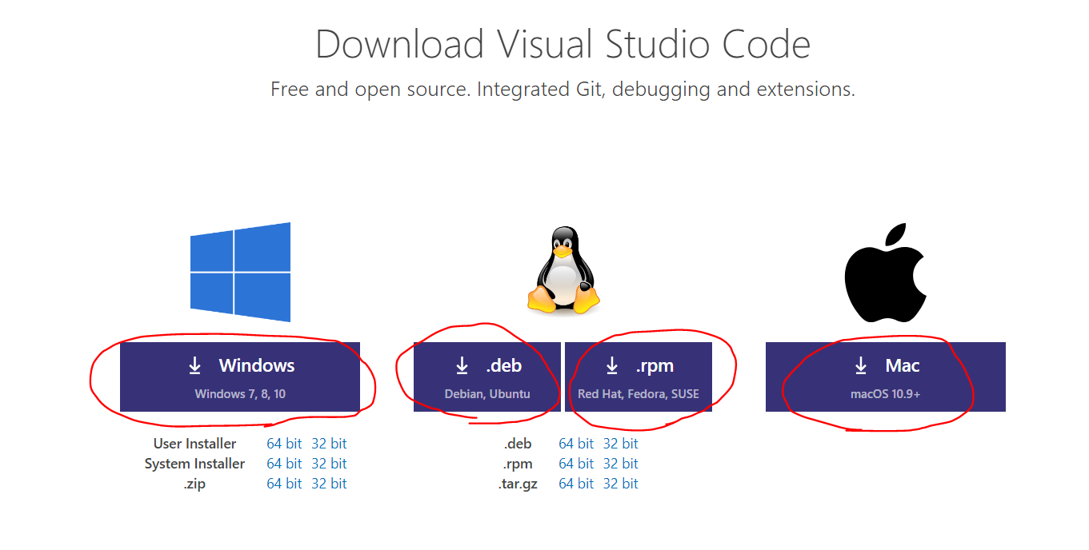

**Step 4:** Once Visual Studio has downloaded go ahead and start the application. Visual Studio Code will aid you in set up. Go ahead and click agree with all the default settings and agree to the terms and conditions.

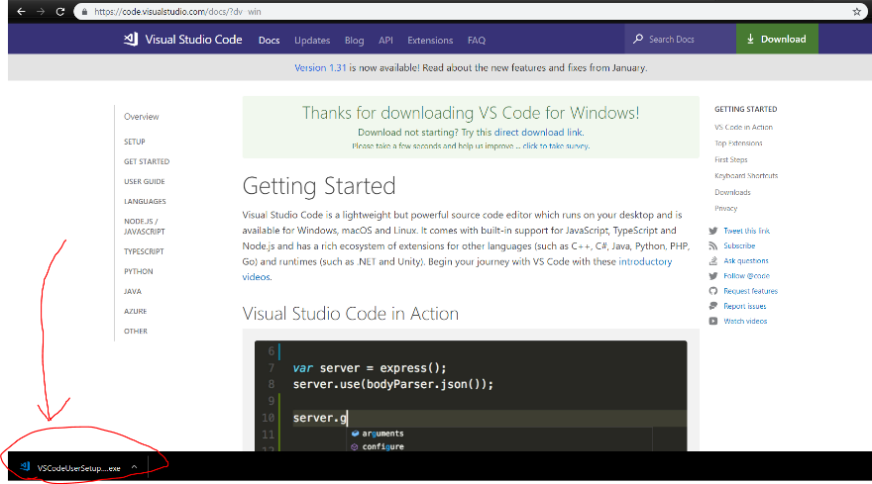

**Step 5:** Next we need to install *Ruby on Rails.* Search “rails installer” on Google and go ahead and click on the first link.

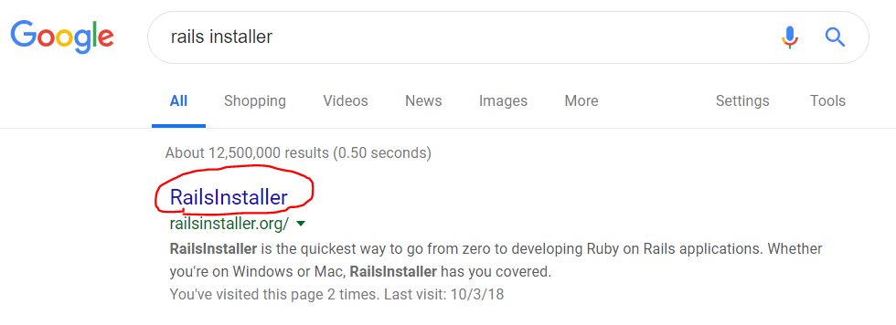

**Step 6:** Choose which version of Ruby on Rails to download depending on the operating system on your computer. Be sure to download the latest version.

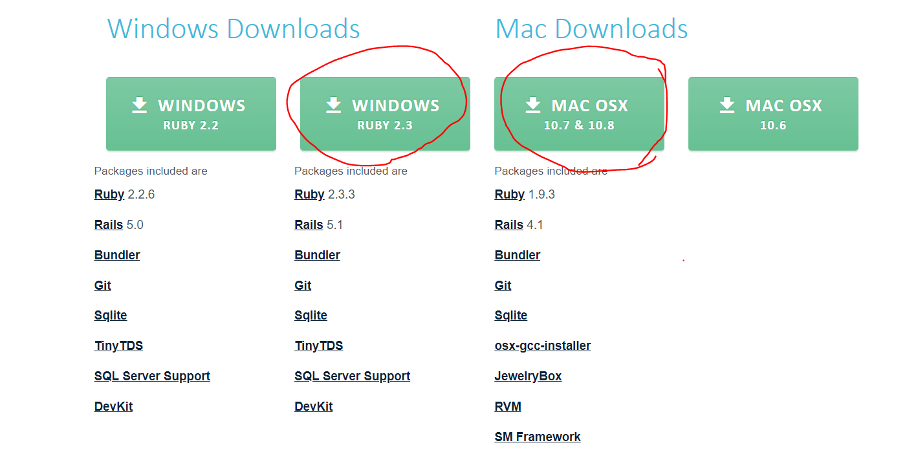

**Step 7:** Go ahead and run the application and agree to all the default setting and to the terms and conditions.

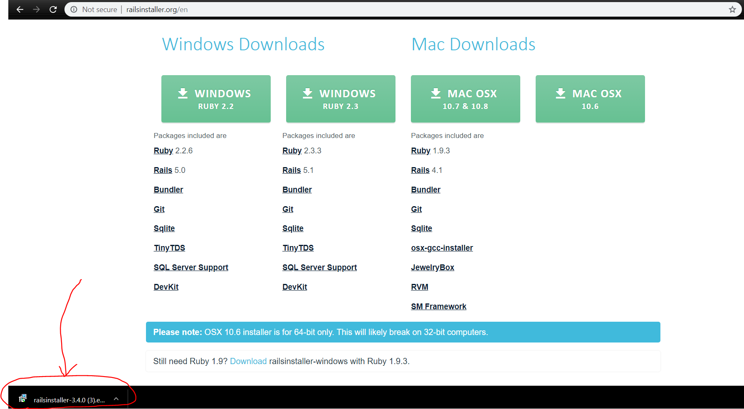

**Step 8:** Go ahead and start up Visual Studio Code we had downloaded earlier. You click on the windows icon and type “visual studio code” on the search tap, then click on *Visual Studio Code*.

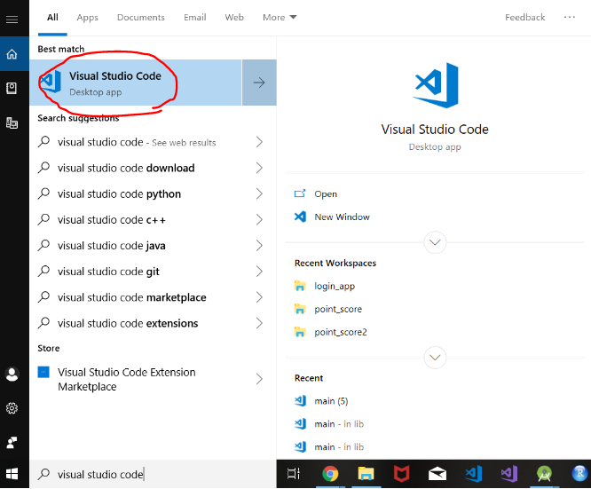

**Step 9:** Once Visual Studio Code is open go ahead and make a new file. You can do this by clicking on File at the top left corner and then clicking on New File.

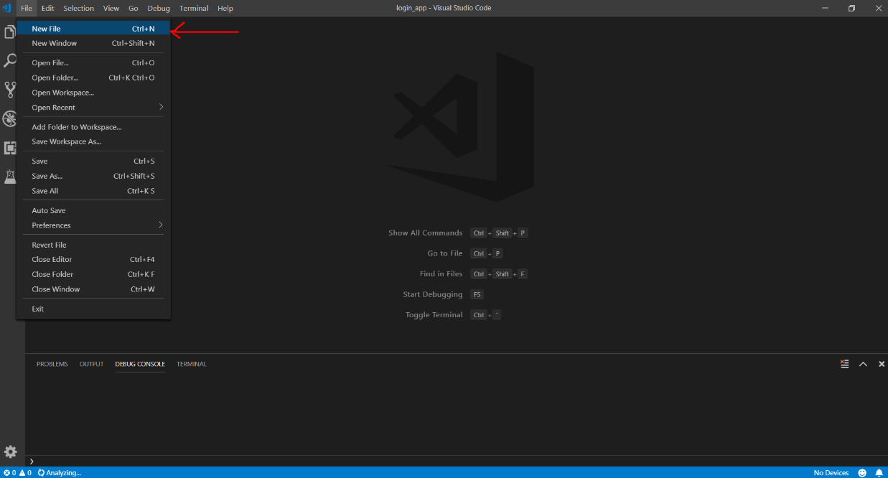

**Step 10:** Go ahead and save that file. I saved mine on my Desktop and named it “helloWorld”. Next on the Save as type: tab, scroll down and let’s save our new file as type Ruby to be able to use the language.

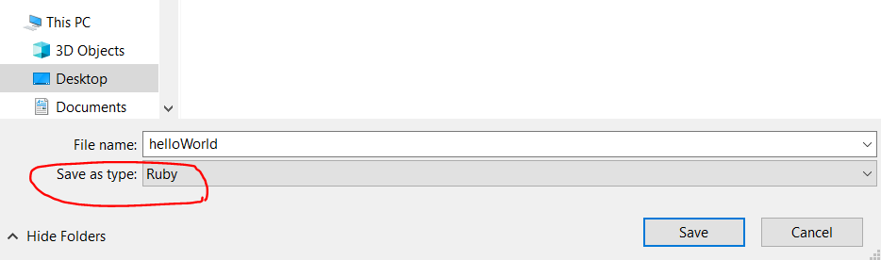

**Step 11:** Now we’re going to write our code. Go ahead and type the following code onto Visual Studio Code. “require ‘sinatra’” calls on a special gem in the Ruby language that will allow us to connect to the server once we run our code. The following code is “get ‘/’ do return “Hello World” end”. Is a function that creates a get request to the server and returns a string “Hello World”. (I can’t go too in depth because it is almost 8).

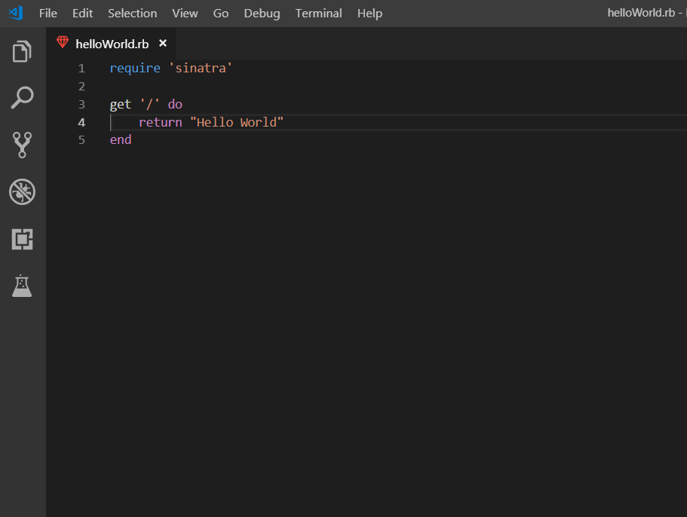

**Step 12:** Open your command screen. You can do this by simply typing “cmd” on the search tab after clicking the windows icon. Next type in “cd Desktop” this will take you to your Desktop where we saved our hellowWorld file.

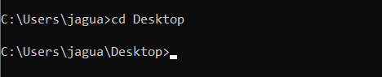

**Step 13:** Next type in “gem install sinatra”. Sinatra is a specific add on to Ruby that will allow our program to connect to the server.

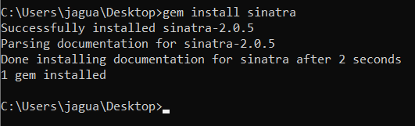

**Step 14:** And now let’s run our code! Go ahead and type in “ruby helloWorld.rb”.

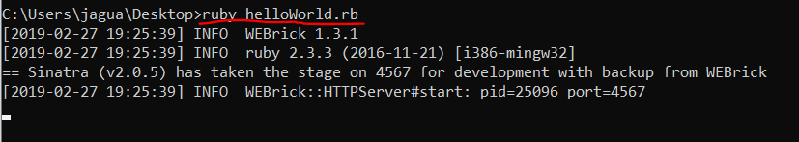

**Step 15:** Play the main theme song from the Matrix.

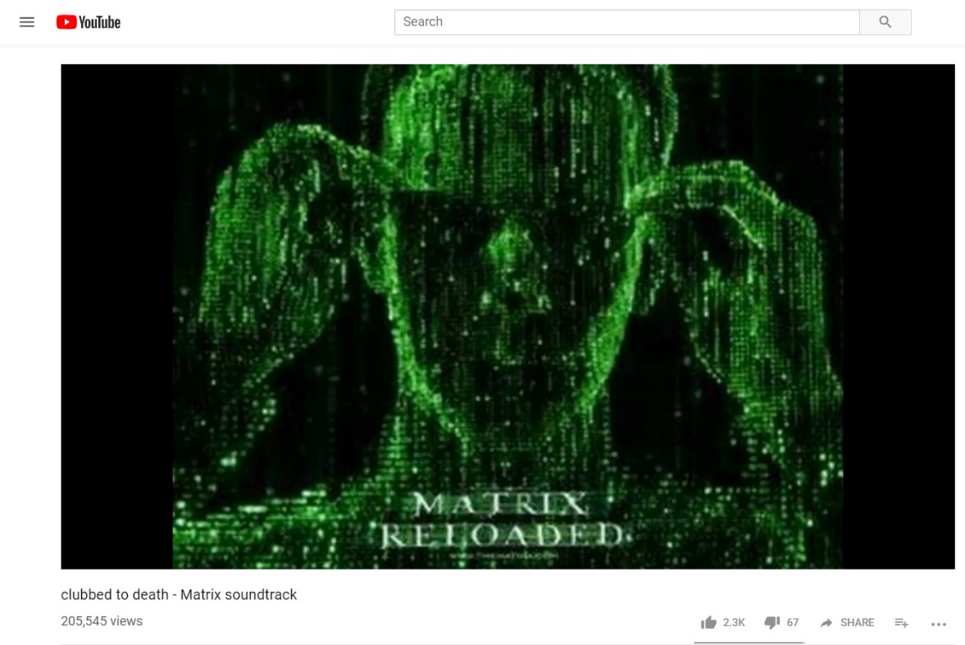

**Step 16:** Go to your internet browser and type “locohost:4567” and watch the fruits of your labor.

